**Lab: Advanced Structured Query Language (SQL) Queries Template**

**Deliverables**:

Write queries that will satisfy the following requirements. To receive credit for this assignment, **all queries must be executed in SQL Server** and be displayed appropriately. For each question:

* **TYPE** the SQL query below the instructions.
* Take a screenshot of your query that was executed in SQL server. **Be sure to capture the query as well as the results in your screen shot.**
* Paste the screenshot below the typed query.

**The first question has been done for you.**

1. Write and execute a query that will return the name and age of all customers. You should have 7 rows in your result:

**Answer**:

This is the query typed out.

select CName, Age

from customer

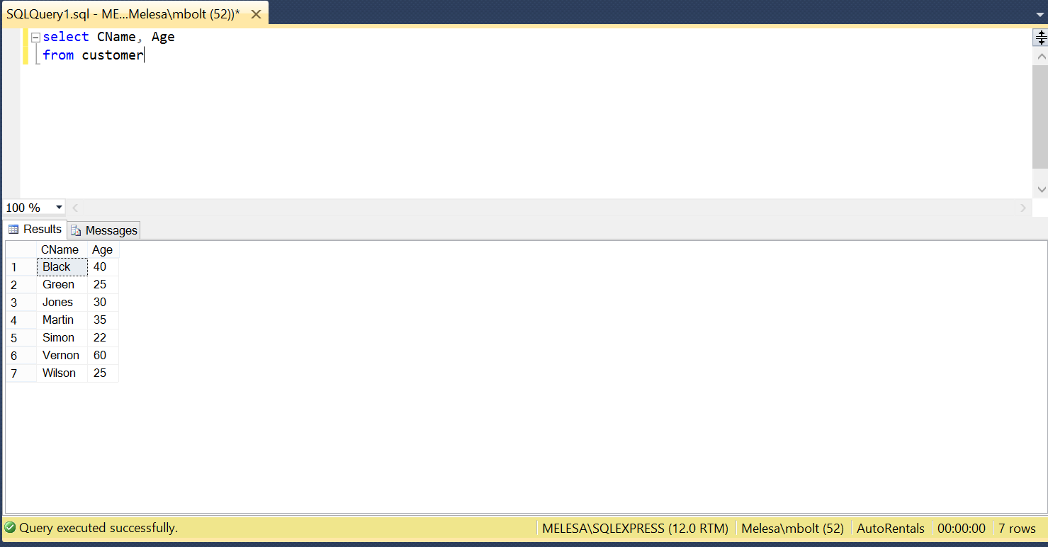

This is the query when executed in SQL Server. Note the capture displays the query, the results, and the number of rows returned.

2. Write and execute a query that will display the name and resid_city of all customers that were born in Tampa.

You should have 3 rows in your result:

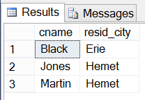

**Answer**:

select cname, resid_city

from Customer

where BirthPlace = 'Tampa'

3. Write and execute a query that will show the customer id and name of customers between the ages of 25 (inclusive) and 40 (inclusive). Order your results by Cname in descending order. Display the CName column with the heading “Customer Name” 🡨 note the capitalizing and the space between words. (Note that you will need to use a column alias for this using the keyword “AS.”)

Your output should look like this:

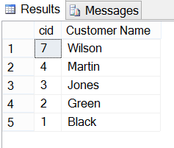

**Answer**:

4. Write and execute a query that will list any customers whose names begin with the letter “G”.

Your query should return 1 row like this:

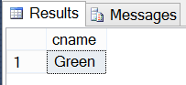

**Answer**:

5. Write and execute a query that will display a **unique** list of all the automobile Makes that have ever been rented. Order your results by Make.

You should have 3 rows in your resultset.

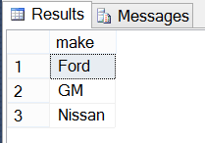

**Answer**:

6. Write and execute a query that will display all of the customers who have ever rented an automobile. Include the customer name, make, pickup location in your results. Order your list in ascending order by pickup.

Your results should include 8 rows:

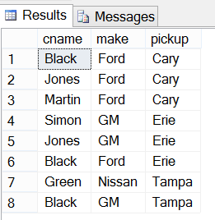

**Answer**:

7. Write and execute a query that will return the names of customers who rented a Ford or GM.

You should have 4 rows in your resultset.

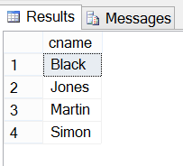

**Answer**:

8. Write and execute a query that will display the customer names, ages, makes, and daily cost of each automobile that they rented. Order your results by cost.

You should have 8 rows in your answer:

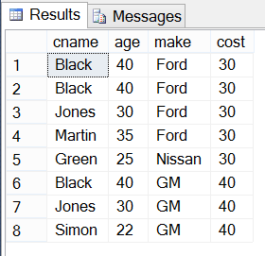

**Answer**:

9. Write and execute a query that will return the **unique** list of birth places of everyone who has ever rented a Ford.

You should have one row in your result: Tampa

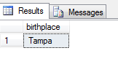

**Answer**:

10. Write a query that will return the Names and ages of customers who have rented any automobile during 2009. Make sure that each customer is listed only once in your output.

You should have two rows in your resultset:

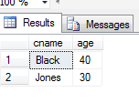

**Answer**:

11. Write and execute a query that will determine the total number of days that Black rented a GM on November 1, 2009.

You should have one cell: 4

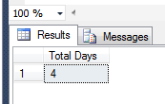

**Answer**:

12. Write and execute a query that will determine the total cost of the automobile rented by Black on November 1, 2009.

You should have one cell: 160

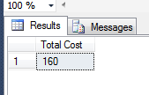

**Answer**:

13. Write and execute a query that will determine the Total cost of all the automobiles that have ever been rented.

You should have one cell: 1880

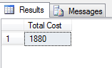

**Answer**:

14. Write and execute a query that will determine the average number of days that automobiles are rented. Show your result broken out by makes. Do not include an automobile if it has not yet been returned.

You should have two rows: Ford and GM with average days rented 13 and 4, respectively.

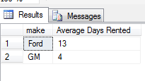

**Answer**:

15. Write and execute a query that will determine the average age of customers broken out by the city in which they reside. Note: Make sure that the average age is not truncated to an integer.

You should have 4 rows: Cary, Denver, Erie, and Hemet with average ages of 42.5, 25, 31, and 32.5

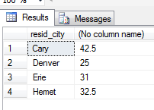

**Answer**:

16. Write and execute a query that will show a list of customers who reside in the same city in which they were born.

You should have 2 rows: Simon and Vernon

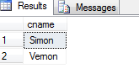

**Answer**:

17. Using a **left outer join**, write and execute a query that will display a **unique** list of the makes of automobiles that have never been rented.

You should have 2 rows: Toyota and Volvo

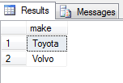

**Answer**:

18. Using a **Type I query**, display a **unique** list of the makes of automobiles that have never been rented.

You should have 2 rows: Toyota and Volvo



**Answer**:

19. Using a **right outer join**, write and execute a query that will display a **unique** list of customers who have never rented an automobile.

You should have two rows: Vernon and Wilson

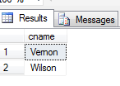

**Answer**:

20. Using a **Type II query**, display a **unique** list of customers who have never rented an automobile.

You should have two rows: Vernon and Wilson



**Answer**:

21. Write and execute a query that will display a list of the customers who picked up their rental from the same city in which they reside.

You should have 2 rows: Black and Simon

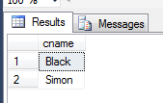

**Answer**:

22. Write a query that will display a list of customers who have not returned their rentals.

You should have 2 rows: Green and Simon

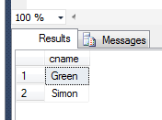

**Answer**:

23. Using a **Type I query**, show all of the names and ages of customers who have rented an automobile and returned it to Erie. Sort your results in ascending order by customer name.

You should have three rows: Black, Jones, Martin.

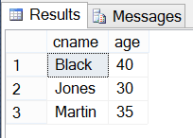

**Answer**:

24. Using a **Type II query**, show all of the customers who rented an automobile and picked it up in Cary.

You should have three rows: Black, Jones, and Martin

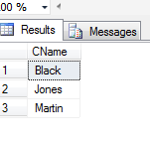

**Answer**:

25. Write and execute a single query that will display **all** of the information in the Customer, Rentals, and Rentcost tables in a single resultset. Be sure to display each field only once in your output. Order your results in ascending order by Customer.CID and Rentcost.Make .

You should have 12 rows and 12 columns in your result.

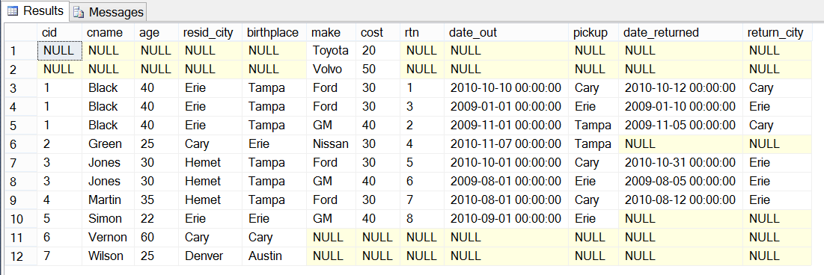

**Answer**: